**Purple Class Newsletter**

**Spring 2024**

I hope we all have a fantastic term of learning and FUN!

**Topic**

Our Topic focus is Geography this half term and the theme is **Rainforests**. We will be looking at the location of rainforests around the world. The children will learn the importance of these areas and how they help stop climate change.

**PE**

Outdoor PE will take place every **Monday and Thursday** and our focus is Netball and Tag Rugby. **Please ensure your child comes in to school wearing their PE kit on Monday and Thursday.**

**Home Learning**

Children are expected to read 5 x per week. They will be expected to complete all their tasks on Google Classroom.

There will be a half term grid linked to Geography, Science and PSHE. Please complete one task each week.

Children will be expected to access **ttrockstars** for Maths. They will also get weekly spellings on Google Classroom.

At the end of Year 4 the children will need to know all the x tables up to 12.

Thanks in advance for supporting your child with this.

**Mrs Barbour**

***PS, please make sure your child is in school on time. Thanks!***



**Mrs Barbour**

***PS Please make sure your child is in school on time. Thanks!***

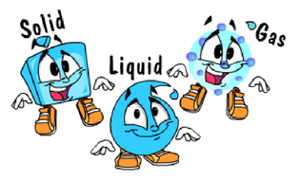

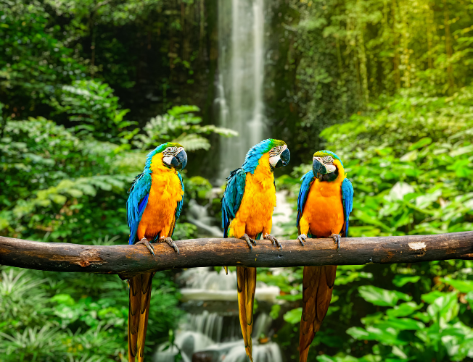

**Hi,**

Happy New Year to you all. I hope you have had a lovely holiday.

In class

Mrs Dorrian and Mrs Flint are our Teaching Assistants. Mrs Doel, Mr Smith and Mrs Rogers will also be teaching some lessons.

Science

Our Topic this half term is **States of Matter.** We will be leaning about solids, liquids and gases and the properties of each. We will be finding out if a gas has weight and why liquids flow at different speeds.